**@ ed and –ing participles**

**I/ COMBINE THE TWO SENTENCES, USING V-ing OR V-ed.**

1. The girl is playing the piano. She is Mai.

__________________________________________________________________

2. The people are waiting for the bus in the rain. They are getting wet.

__________________________________________________________________

3. I live in a pleasant room. The room overlooks the garden.

__________________________________________________________________

4. Most of the goods are exported. The goods are made in this factory.

__________________________________________________________________

5. I come from a city. The city is located in the northern part of the country.

__________________________________________________________________

6. The ruler is made of plastic. It is nice.

__________________________________________________________________

7. The girl is talking to Phan. She is Australian.

__________________________________________________________________

8. The man was wanted by police. He is arerested now.

__________________________________________________________________

9. The dancers are dancing beautifully. They were trained in Russia.

__________________________________________________________________

10. The boy is swimming in the pool. He was the school champion last years.

**II. READ AND ANSWER THE QUESTIONS.**

Vietnam is a country in the South – East Asia. It has an area of 329,566 sq.km. Hanoi is the capital and Ho Chi Minh City is the largest city. The population of Vietnam is about 80 million. It has age-old culture and long tradition of fighting against foreign invaders. Vietnam is now a member country of ASEAN and many other international originations such as APEC, WTO...

Vietnam exports rice, coffee and many other farm products. Vietnam has lots of tourist attractions and World Heritage Sites such as Ha Long Bay, Phong Nha Cave, Hoi An Ancient Town, My Son Sanctuary, etc. Vietnamese people are proud of their country. They have been trying hard to build into a power and prosperous one.

1. Where is Vietnam located?

__________________________________________________________________

2. What is the area of Vietnam?

__________________________________________________________________

3. What does Vietnam export?

__________________________________________________________________

4. Name some World Heritage Sites in Vietnam.

__________________________________________________________________

**III. Work with a partner. Look at the pictures. Ask questions and give suitable responses. The information on page 100 may help you.**

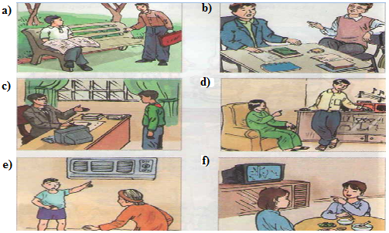

**a) Request:** Do you mind if I sit down?

**Response:** Please do.

**b) Request:** Would you mind if I smoked?

**Response:** I'd prefer you didn't.